* Population:

The population in a statistical study is the ________________________________________________________.

* Census: A census collects data from _________________________________________________________.
* Sample:

A sample is a _____________________________________ in the population from which we collect data

* Sampling method: _____________________________________________________________________.
* Good sample: ______________ (to _____________ the inference from the sample to the population)
* Bad sample (bias)
* _________________ bias: Selecting individuals from the population who are easy to reach.
* _________________ bias: Allowing people to choose to be in the sample by responding to a general invitation.
* _________________ bias**:** Some groups in the population are left out.
* _________________ bias**:** tendency to provide inaccurate or even false, answers to self-report questions
* _________________ bias**:** Data are not obtained from all individuals in the sample.
* _________________ bias: when the wording of a question systematically influences the responses
* FRQ: “describe how the design of a sample survey leads to bias”

**Exam Tip:**

* Recognize the type of bias
* Describe how the members of the sample might respond differently from the rest of the population
* underestimate or overestimate the actual proportion/mean/…
* **Example:**

Explain how using your statistics class as a sample to estimate the proportion of all high school students who own a graphing calculator could result in bias.

* Sample without replacement:

Once an individual from the population is selected for inclusion in the sample, it ________________________________ ___________________________________________________.

A sample selected without replacement includes n _________________ individuals from the population.

* Sample with replacement:

After an individual from the population is selected and the corresponding data are recorded, the individual is ____________ in the population and ________________________ in the sampling process.

A sample selected with replacement might include any particular individual from the population more than once.

* good methods of sampling
* Simple random sampling:

Ensure that every different possible sample of the desired size has the _________________________________.

**[FRQ]**

* **Label:** Give each member of the population a **___________** numerical label with ________________.
* **Randomize:**
* Read ___________ groups of digits of the appropriate length ______________ across a line in the table.
* ____________ any group of digits that _________________ or that __________________ in the sample.
* _________ when you have chosen n different labels.
* **Select:** Choose the individuals that _________________________________.

**[Example] How Much Do Fans Love Justin Timberlake?**

JT’s concert promoter wants to find out how much fans enjoy the concerts. He will ask fans, “From 1 to 100, where 100 is the most, how much did you enjoy the concert?” The section he wants to survey has 50 seats (5 rows x 10 columns). The stage runs along the northern edge of the venue (where Justin is pictured). He wants to take a sample of 10 seats.

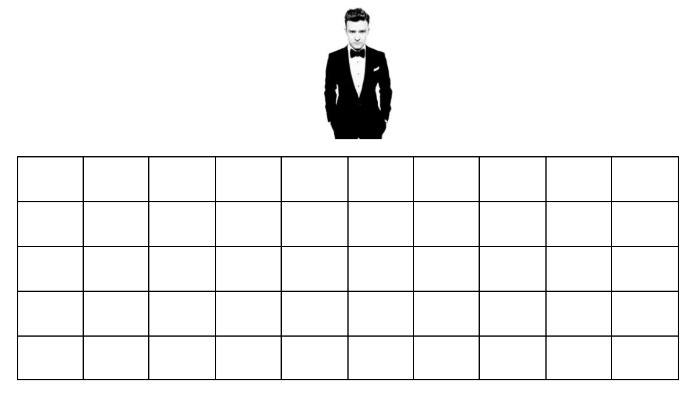

Q: Take a simple random sample (SRS) of 10 fans. Explain below the steps you used to obtain an SRS.

1. **Label**
2. **Randomize**
3. **Select**

* **Practice**
* Systematic sample
* Cluster sample
* Stratified random sample

